Prepared By:

Chiranjeevi (1401),

S.E.

C:\Users\chiranjeevi.g\Downloads\image001.png

**IBM IOC MS V5.1.0.4 HA with common internal HDD shared disk LVM**

**Prerequisites:**

**Softwares Required:**

1. rhel-server-6.6-x86_64-dvd.iso
2. RMC-3.1.1.0-x86-Linux.tar.gz
3. IBM_IOC_MultiSer_1of4_Lin_ML.iso
4. IBM_IOC_MultiSer_2of4_Lin_ML.iso
5. IBM_IOC_MultiSer_3of4_Lin_ML.iso
6. IBM_IOC_MultiSer_4of4_Lin_ML.iso

IBM Intelligent Operations Center uses the power of the real-world data that is generated by computer systems by performing the following tasks:

* Collecting and managing the right data
* Integrating and analyzing that data
* Facilitating easy and timely access to information
* Presenting related information in a coherent way

url: http://www-03.ibm.com/software/products/en/intelligent-operations-center

IBM Intelligent Operations Center helps government leaders manage complex city environments, incidents and emergencies with a city solution that delivers operational insights. It offers integrated data visualization, near real-time collaboration and deep analytics to help city agencies enhance the ongoing efficiency of city operations, plan for growth and coordinate and manage response efforts. IBM Intelligent Operations Center provides integrated maps, online dashboards, customizable reports, multiple analytic algorithms, interactive standard operating procedures and other tools for improved city operations and incident or emergency response.

IBM Intelligent Operations Center enables you to:

* Monitor and manage resources, events and incidents through situational awareness.
* Optimize city growth and operations through deep analysis of the city environment and resources.
* Stay connected with citizens and address their concerns through citizen collaboration tools and services.
* Keep citizens safer with crime risk hot-spot analytics.
* Integrate data from various departments and agencies through a common platform.

**Monitor and manage resources, events and incidents**

* Use cross-agency visualization capabilities to give decision makers a near real-time, unified view of city operations so they can make more informed decisions in day-to-day operations as well as times of crises and heightened response.
* View the overall status of city operations in near real-time so the city officials see what resources are needed and available.
* Drill down to get insight into each underlying agency, such as emergency management, public safety, social services, transportation and water.
* Take advantage of near real-time communication and collaboration among city agencies for more effective response management and coordination for disasters, incidents and events.

**Optimize** **city growth and operations**

* Gain more insight into where the city is growing and what factors are contributing to its growth.
* Share centralized information for city-wide integration of daily operations and enable visibility into key performance indicators (KPIs), trends, analyses, business rules and cross-agency collaboration.
* Analyze programs and initiatives against established goals.
* Establish departmental and agency KPIs and monitor them against standard operating procedures that you define.

**Stay connected with citizens and address their concerns**

* Enable citizens to use social and mobile tools to report issues and incidents quickly through the collaboration platform.
* Help reduce some city staffing requirements as more citizens participate and report incidents.
* Notify citizens and businesses directly when issues are addressed, creating more two-way communication and collaboration.
* Combine reported problems with other sources of information to schedule repairs, spot trends and optimize responses.

**Keep citizens safer**

* Help identify the latest trends and predictions for anticipated crimes, enabling city officials to act more proactively.
* Highlight areas of possible criminal activity using hot spots marked on a geo-spatial map.
* See hot spots evolve in near real-time.
* Identify crime patterns to help make more informed decisions.

**Integrate data from departments and agencies**

* Bring data together from various city departments and agencies using one common smarter cities platform.
* Develop custom services using a common platform that provides agencies and developers with access to city-wide data.
* Enable cities with IT resources to deploy software on premise with the security measures they require.
* Enable cities without IT resources to deploy the software as a service in the IBM SmartCloud with no upfront capital expense.

**IBM Intelligent Operations Center Architecture:**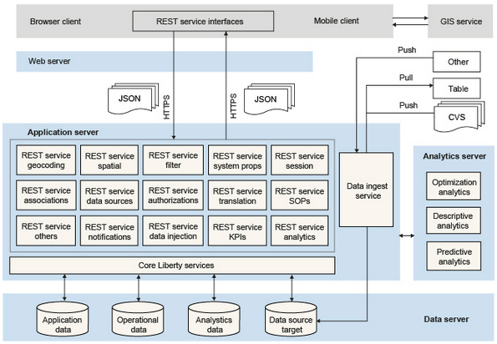

# Installing the multi-server platform and application

Install the following Red Hat Package Manager (RPM) files that are required by the IBM Intelligent Operations Center installation:

1. Mount the rhel-server-6.6-x86_64-dvd.iso file to the system.   
2. Select open a terminal window as a root.  
3. Execute the commands:   
[root@localhost]# mkdir /mnt/cdrom  
[root@localhost]# mount -o ro /dev/cdrom /mnt/cdrom  
4. Create the text file server.repo in the /etc/yum.repos.d directory.   
Note: To use gedit, execute the command:

[root@localhost]# gedit /etc/yum.repos.d/server.repo  
Add the following text to the file:   
  
[server]  
name=server  
baseurl=file:///mnt/cdrom/   
enabled=1  
  
where baseurl depends on the mounting point and the RHEL distribution.   
  
In the example, the mounting point is cdrom and the RHEL distribution is Workstation but could be sever.  
  
5. Execute the command:  
[root@localhost]# yum clean all  
6. Execute the command to import related public keys:  
[root@localhost]# rpm --import /mnt/cdrom/*GPG*  
7. Execute the commands to install the required libraries:  
[root@localhost]# yum install gtk2.i686  
[root@localhost]# yum install libXtst.i686  
If you received the missing libstdc++ message above, install the libstdc++ library:  
[root@localhost]# yum install compat-libstdc++  
yum install the following libraries as well

* yum install audit-libs.i686
* yum install audit-libs.x86_64
* yum install compat-libstdc++*i686
* yum install dos2unix.x86_64
* yum install gettext.x86_64
* yum install glibc.i686
* yum install glibc.x86_64
* yum install ksh.x86_64
* yum install libaio.i686
* yum install libaio.x86_64
* yum install libgcc.i686
* yum install libgcc.x86_64
* yum install libstdc++.i686
* yum install nss-softokn-freebl.i686
* yum install nss-softokn-freebl.x86_64
* yum install ntp.x86_64
* yum install openssh-clients.x86_64 pam.i686
* yum install pam-devel.i686
* yum install pam_passwdqc.x86_64
* yum install tcsh.x86_64 unzip.x86_64
* yum install xorg-x11-xauth.x86_64
* yum install zlib.i686 zlib.x86_64
* yum install gtk2.i686 gtk2.x86_64
* yum install gtk2-engines.i686
* yum install gtk2-engines.x86_64 libXtst.i686
* yum install libXtst.x86_64
* yum install nfs-utils
* yum install iscsi-initiator-utils
* yum groupinstall "Network Storage Server"
* rpm -ivh /root/Desktop/iscsi-initiator-utils-6.2.0.873-21.el6.x86_64.rpm
* yum install iscsi*

During the install you might receive prompts similar to the example. Answer with 'y'.

Do the following steps on each of the four servers.

* Data server
* Analytics server
* Application server
* Web server

1. Open a terminal window, and log on as a root user.
2. Define a fully qualified name and short host name either by using a DNS server, or by creating a definition in the /etc/hosts file.

Note: Ensure that the database server host name is not the same as either of the following database names:

* + IOCDB
  + IOCDATA

1. Ensure that the HOSTNAME value that is defined in the /etc/sysconfig/network file is set to the short host name, and that it is not set to the fully qualified host name. For example, set HOSTNAME=xyz instead of HOSTNAME=xyz.yourco.com.
2. Verify that the host name, fully qualified host name, and domain name are configured correctly on each server:
   * Enter the following command: hostname -s. The verification is successful if the command returns the defined short host name for the server.
   * Enter the following command: hostname -f. The verification is successful if the command returns the fully qualified domain and host name for the server.
   * Enter the following command: hostname -d. The verification is successful if the command returns the domain name of the server.
3. In the /etc/selinux/config file, configure the SELinux setting to either permissive or disabled. For example, to configure the SELinux setting to permissive, in the /etc/selinux/config file, edit the SELinux setting as shown in the following example and then restart the server:

SELINUX=permissive

Note: The SELinux setting must not be enabled.

1. Reboot the operating system using the following command to make the SELinux changes effective:

reboot

1. To disable the server firewalls, enter the following commands:

service iptables save

service iptables stop

chkconfig --level 123456 iptables off

1. To install the prerequisite RPM files, enter the following command:

yum install -y audit-libs.i686 audit-libs.x86_64 compat-libstdc++*i686 compat-libstdc++_*x86_64 dos2unix.x86_64 gettext.x86_64 glibc.i686 glibc.x86_64 ksh.x86_64 libaio.i686 libaio.x86_64 libgcc.i686 libgcc.x86_64 libstdc++.i686 nss-softokn-freebl.i686 nss-softokn-freebl.x86_64 ntp.x86_64 openssh-clients.x86_64 pam.i686 pam-devel.i686 pam_passwdqc.x86_64 tcsh.x86_64 unzip.x86_64 xorg-x11-xauth.x86_64 zlib.i686 zlib.x86_64 gtk2.i686 gtk2.x86_64 gtk2-engines.i686 gtk2-engines.x86_64 libXtst.i686 libXtst.x86_64 nfs-utils

1. Install the Red Hat Enterprise Linux packages for the X Window System on the analytics, application, and web servers.

X Windows is not required for the initial installation of IBM Intelligent Operations Center, but it is required if you want to update the underlying IBM products by using IBM Installation Manager. For example, you can update WebSphere Application Server Liberty Profile and IBM HTTP Server. You can install either the GNU Object Model Environment (GNOME) desktop or the K Desktop Environment (KDE) desktop to use with IBM Installation Manager.

Note: DB2 does not use the IBM Installation Manager, so the data server does not require the graphical user interface (GUI) that is provided by either the GNOME desktop or the KDE desktop.

1. Choose one of the following options:
   * To install the GNOME desktop, enter the following command:

yum -y groupinstall "X Window System" Desktop

* + To install the KDE desktop, enter the following command:

yum -y groupinstall "X Window System" "KDE Desktop"

1. Enter the following command: yum -y update
2. To start the desktop, enter the following command: init 5
3. To configure the GUI desktop to be the default desktop, edit the /etc/inittab file and change the value of the initdefault property from 3 to 5. The following example shows the updated line:

id:5:initdefault:

1. Save the changes, and then restart the server.

## NFS Server

## Procedure

1. Enter the following commands in a terminal window as the root user to create directories either on the analytics server, or on analytics server 1 in a high availability environment, or on an NFS server:
2. mkdir /solution_iso_images
3. mkdir /solutionmedia

mkdir /installmedia

1. Copy the following ISO image files into the /solution_iso_images directory:
2. IBM_IOC_MultiSer_1of4_Lin_ML.iso
3. IBM_IOC_MultiSer_2of4_Lin_ML.iso
4. IBM_IOC_MultiSer_3of4_Lin_ML.iso

IBM_IOC_MultiSer_4of4_Lin_ML.iso

1. Enter the following commands to extract the contents of each of the four ISO image files to the /installmedia directory:
2. cd /solution_iso_images
3. mount -o loop IBM_IOC_MultiSer_1of4_Lin_ML.iso /solutionmedia
4. cp -r /solutionmedia/* /installmedia/
5. umount /solutionmedia
6. mount -o loop IBM_IOC_MultiSer_2of4_Lin_ML.iso /solutionmedia
7. cp -r /solutionmedia/* /installmedia/
8. umount /solutionmedia
9. mount -o loop IBM_IOC_MultiSer_3of4_Lin_ML.iso /solutionmedia
10. cp -r /solutionmedia/* /installmedia/
11. umount /solutionmedia
12. mount -o loop IBM_IOC_MultiSer_4of4_Lin_ML.iso /solutionmedia
13. cp -r /solutionmedia/* /installmedia/
14. umount /solutionmedia

rmdir /solutionmedia

1. On the analytics server, or on analytics server 1 in a high availability environment, or on the NFS server where you extracted the media, configure an NFS export:
   1. Create the /etc/exports file if it does not exist.
   2. Edit the /etc/exports file, and add the following line:

/installmedia/ *(ro,sync)

* 1. Enter the following command to start rpcbind and the NFS server:

service rpcbind start; service nfs start

* 1. Enter the following command to check the NFS server status:

service nfs status

* 1. Enter the following command to verify that the mount is exported:

showmount -e localhost

1. On each of the servers that do not have the media extracted into /installmedia, create an NFS mount to the /installmediadirectory:
   1. Enter the following command to start the NFS server:

service nfs start

* 1. Enter the following command to create the /installmedia directory:

mkdir /installmedia

**Note:** If the /installmedia directory exists, ensure that the directory is empty. The directory must be empty for the mountcommand to work correctly.

* 1. Enter the following command to verify that the mount is available:

showmount -e analytics or NFS file server hostname

A list of available mount points are listed. If the /installmedia directory is correctly mounted, it is displayed as an option. The following example shows the command and the resulting output:

#showmount -e ioc51anal

Export list for ioc51anal:

/installmedia *

* 1. Enter the following command to mount the /installmedia share locally on the server with an NFS mount tool:

mount -t nfs ioc51ana:/installmedia /installmedia

* 1. Repeat steps 5.a to 5.d on each of the servers that does not have the media extracted to the /installmedia directory.

1. On each of the servers, create an installation directory and copy the ioc_platform.tar.gz compressed installation file to the installation directory:
   1. Open a terminal window and log on as the root user.
   2. Enter the following command to create the base IBM Intelligent Operations Center installation directory:

mkdir -p /opt/IBM/

* 1. Enter the following command to copy the ioc_platform.tar.gz installation file from the /installmedia directory to the base IBM Intelligent Operations Center installation directory:

cp /installmedia/ioc_platform.tar.gz /opt/IBM/

**LVM Creation Guide**

**Logical Volume Management:**

LVM stands for Logical Volume Management. It is a system of managing logical volumes, or filesystems that is much more advanced and flexible than the traditional method of partitioning a disk into one or more segments and formatting that partition with a filesystem.

**The Basics**

There are 3 concepts that LVM manages:

* Physical Volumes
* Volume Groups
* Logical Volumes

A *Volume Group* is a named collection of physical and logical volumes. Typical systems only need one *Volume Group* to contain all of the physical and logical volumes on the system, and I like to name mine after the name of the machine. *Physical Volumes* correspond to disks; they are block devices that provide the space to store logical volumes. Logical volumes correspond to partitions: they hold a filesystem. Unlike partitions though, logical volumes get names rather than numbers, they can span across multiple disks, and do not have to be physically contiguous.

**Installation**

In this guide, we will create LVM on RHEL server and share a disk partition with multiple servers.

**LVM Server**

To create a LVM partition we need to first setup the LVM server and create PV, LV and VG on that LVM server.

We will create PV at the time of creation of the VM and VG, LV after Vm creation. The steps as follows:

**VM Creation:**

1) Create New VM as analytical server for IOC HA environment and choose Typical option to create VM with our own configurations

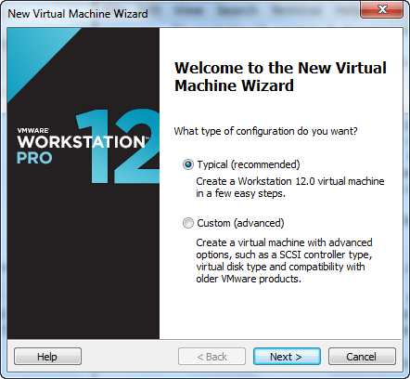

2) Choose lat option to create VM without any OS. It is advisable for the HDD partition while creating VM.

Click on “**I will install the operating system later**” and click **Next.**

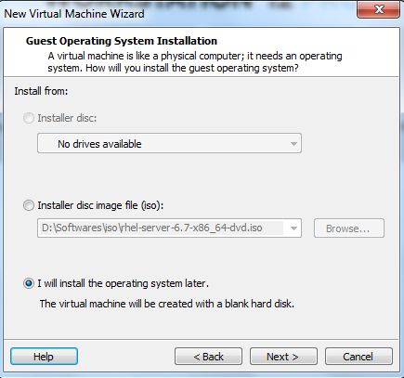

3)Select Linux operating system to be created as VM

Select Linux and click **Next**.

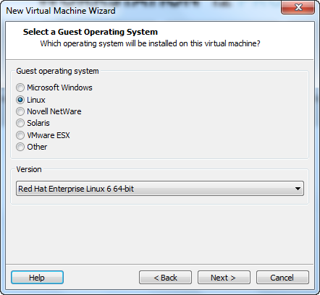

4) Provide the VM name and location to save that and click **Next**.

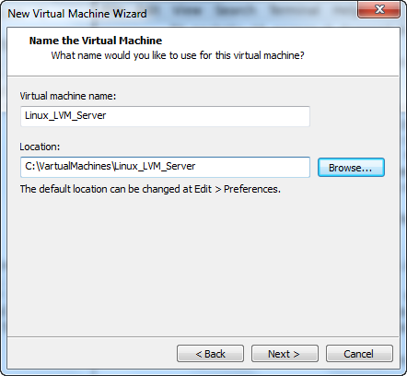

5)Provide disk space and select Store virtual disk as a single file option

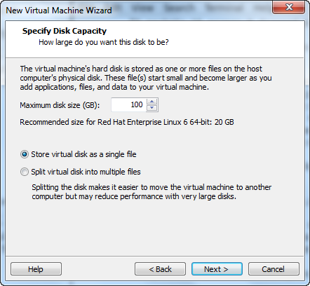

6) Click on Customize Hardware option to configure network adapter , MAC address and to browse for operating system .iso file

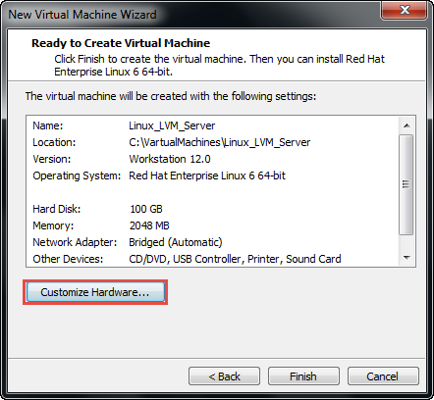

7) Select Network Adapter and choose Network Connection as Bridge connectivity 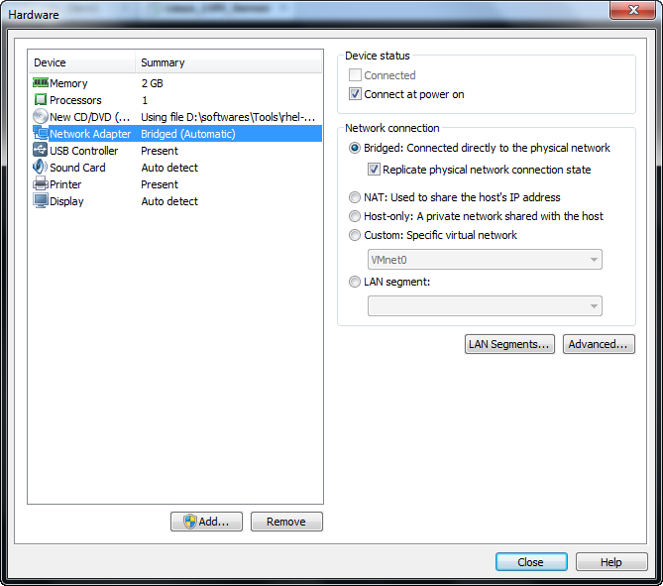

8) Click on Advanced option for Network adapter and generate new MAC address and add this MAC address to the network to get internet and to communicate with other systems in the network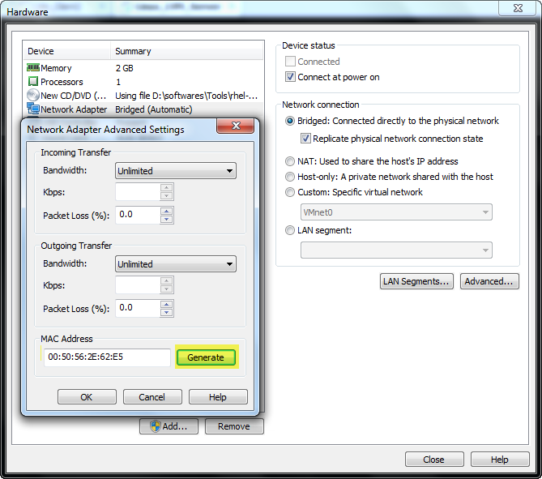

9) Browse for linux operating system .iso file in the SATA device option 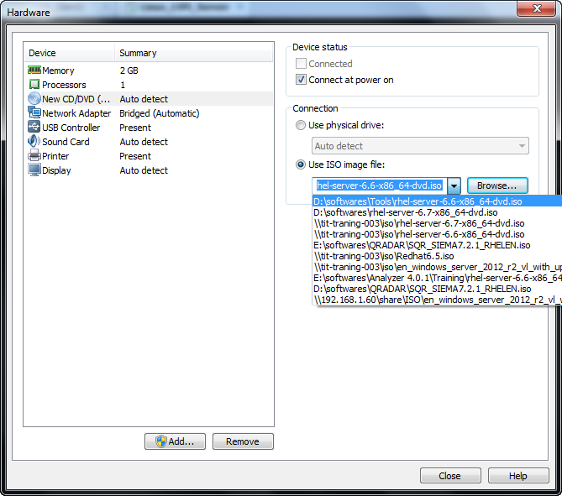

10)Select install an existing system option to start installing the Linux VM with our existing configurations

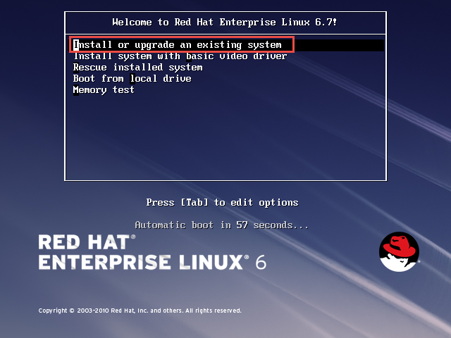

11)Skip the testing of installation media for errors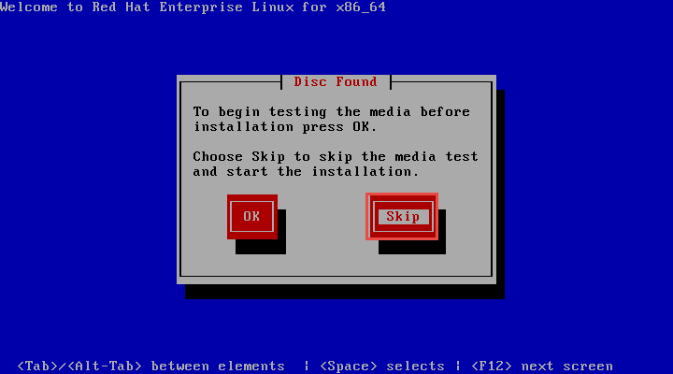

12)Click on **Next** to proceed RedHat Linux VM creation

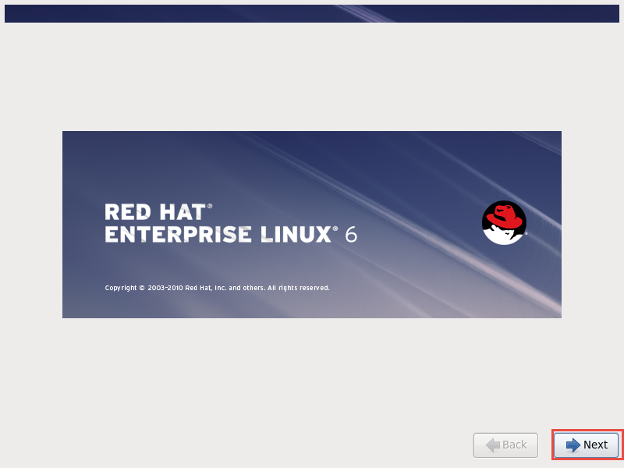

13)Choose English option for language settings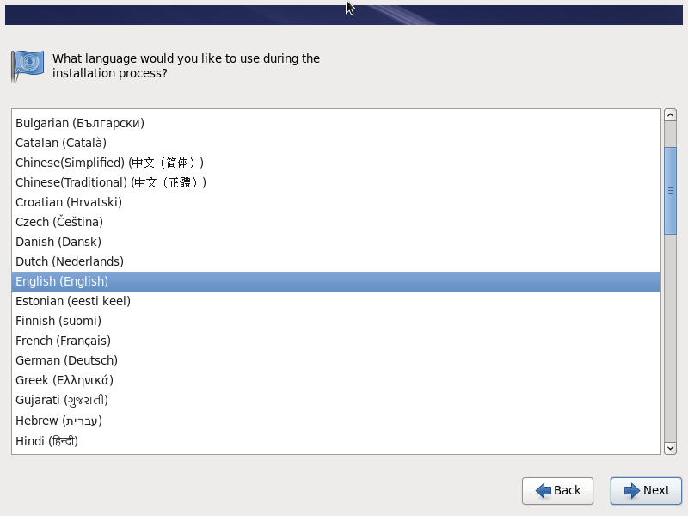

14)Choose U.S English for keyboard settings 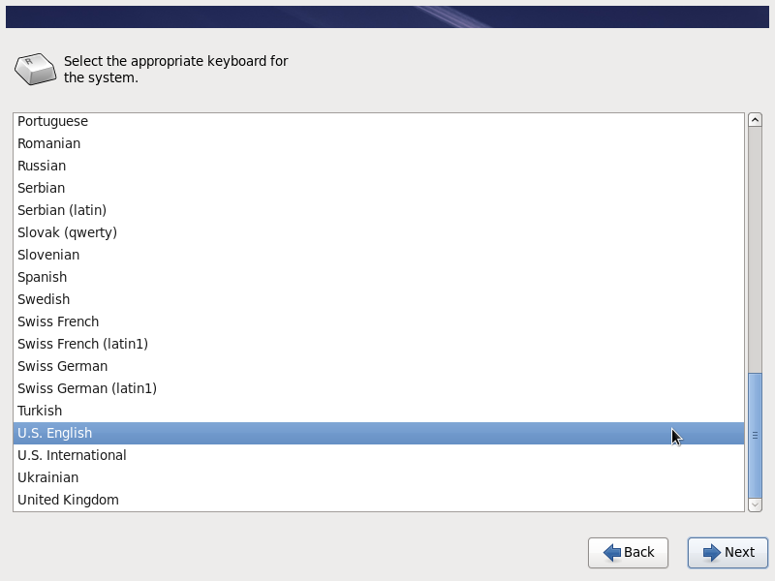

15)Click on Yes to discard any data to format on the disk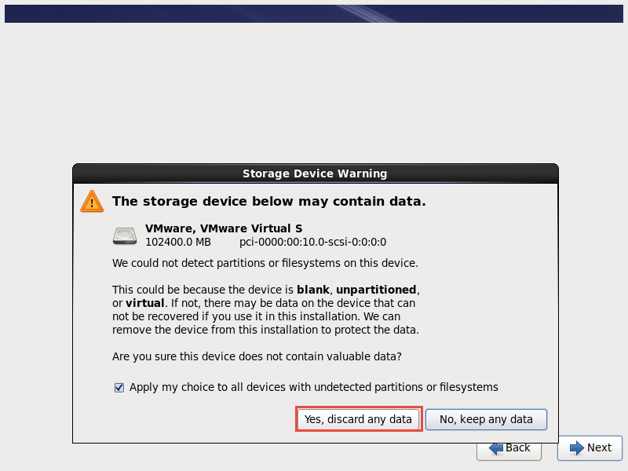

16)Keep localhost as default hostname , later if you want you can change in /etc/hosts file

Click Next to proceed VM creating 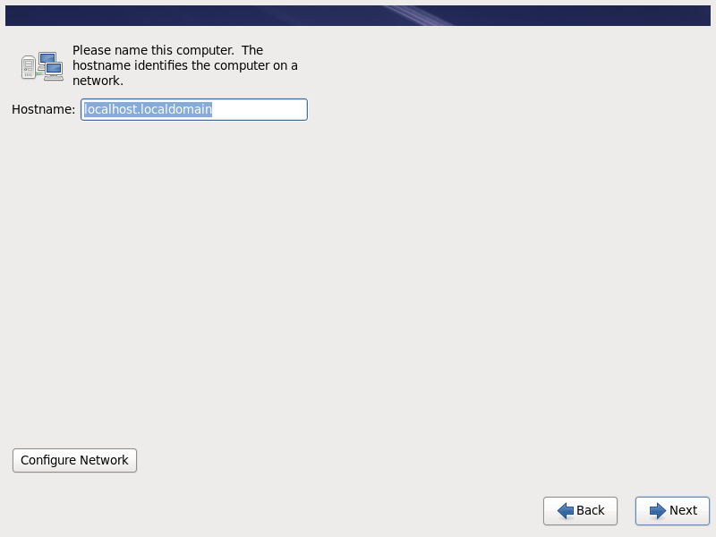

17)Select TimeZone settings

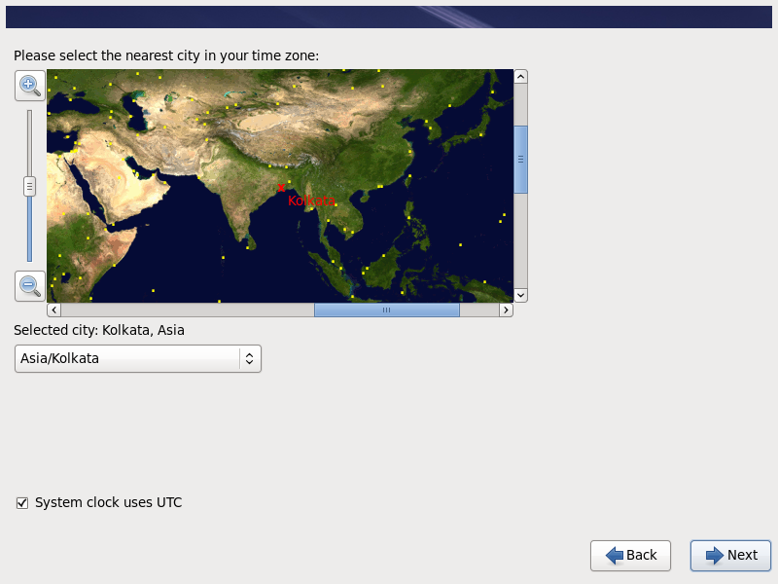18)Give password for Root user of the VM

Click on Use AnyWay for weak password 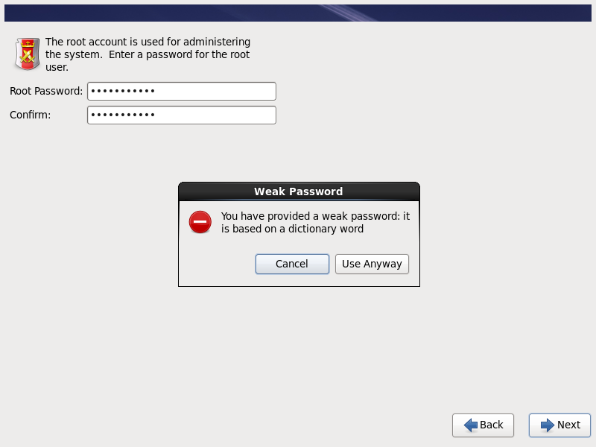

19)Choose Create Custom Layout for for disk partition 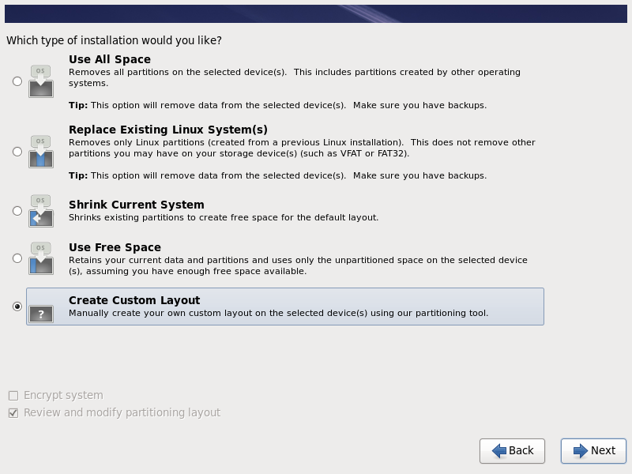

20) Create disk partitions for the OS bootable drive ,swap memory and for LVM drive 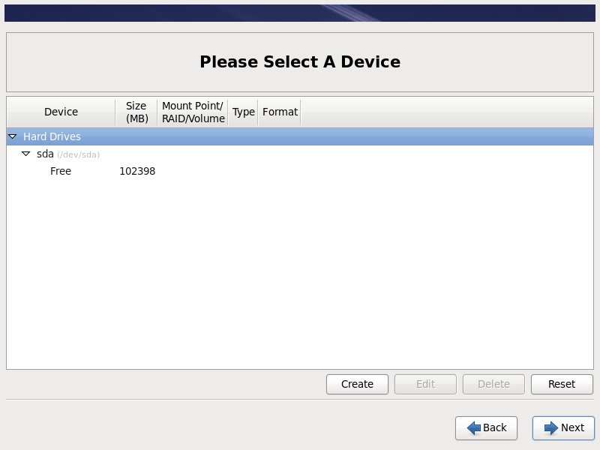

21) Choose **Standard partition** option to **create** standard disk partition

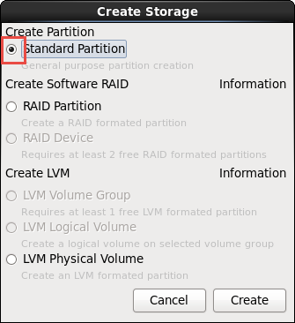

22) Create boot partition by select **/boot** Mount point for OS bootable drive as ext4 file system type and click ok to proceed 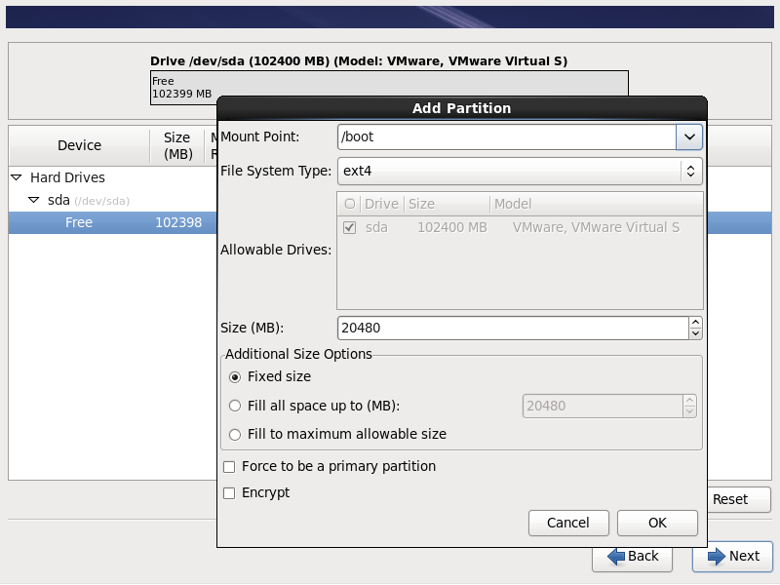

23) Choose **Standard partition** option to **create** standard disk partition as step 21



24) Choose **Standard partition** option to **create** standard disk partition as step 21



25)Create external partition by select / for the external storage 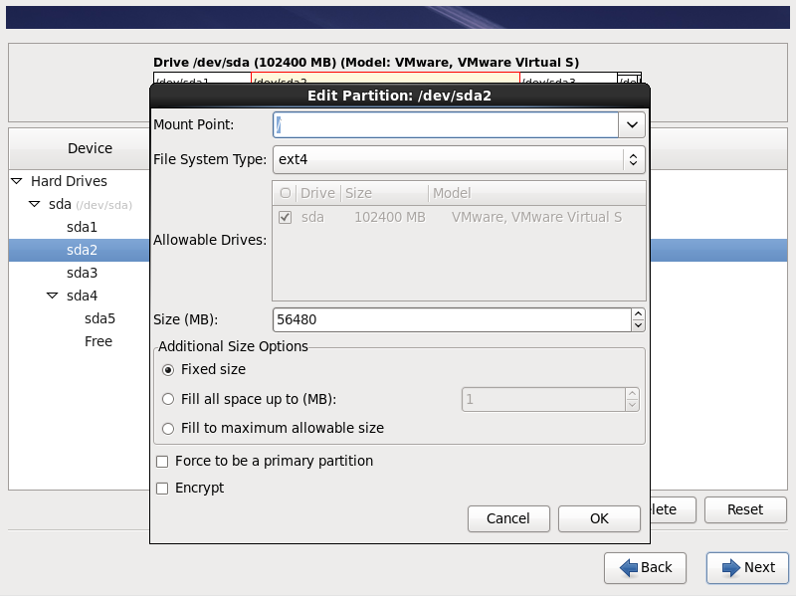

26)Create **SWAP** partition by selecting file system type as **swap** to provide extended memory space for RAM

Note: Provide swap memory as double the RAM 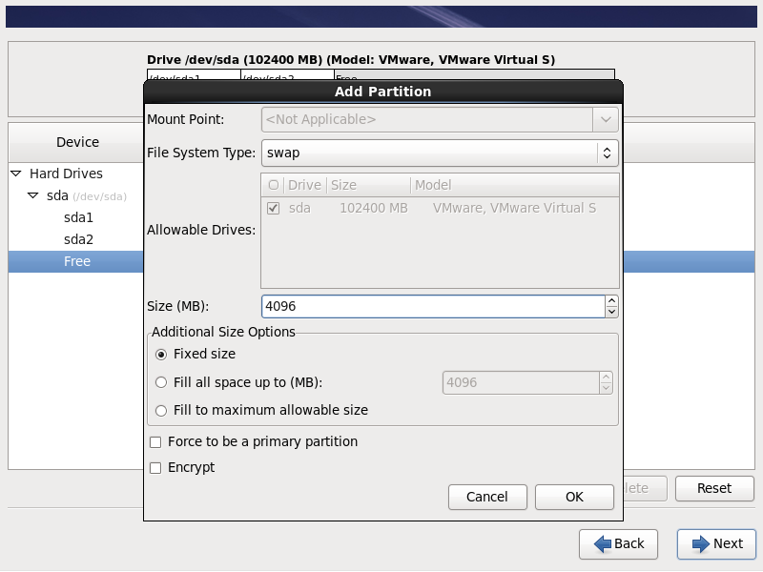

27) Choose **LVM Physical Volume** option to **create** LVM(Logical volume manager) disk partition

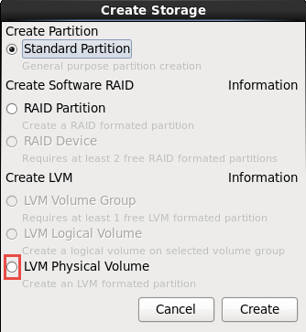

28) Create LVM physical volume partition by selecting physical volume (LVM) option and click ok. 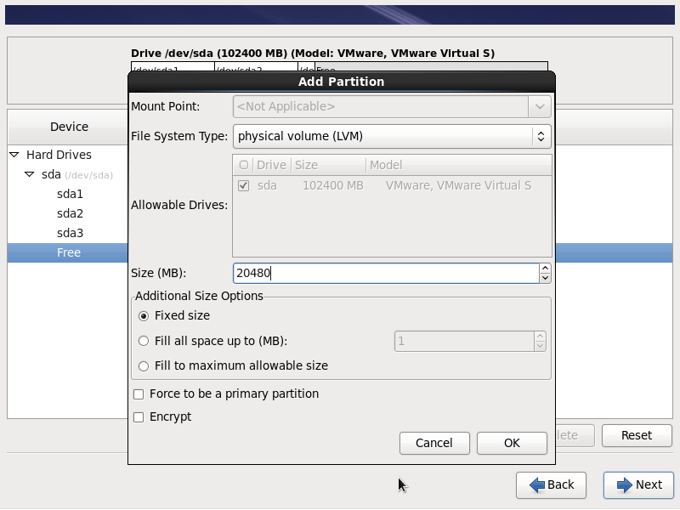

29)Click on **Next** once you have done with the disk partitions 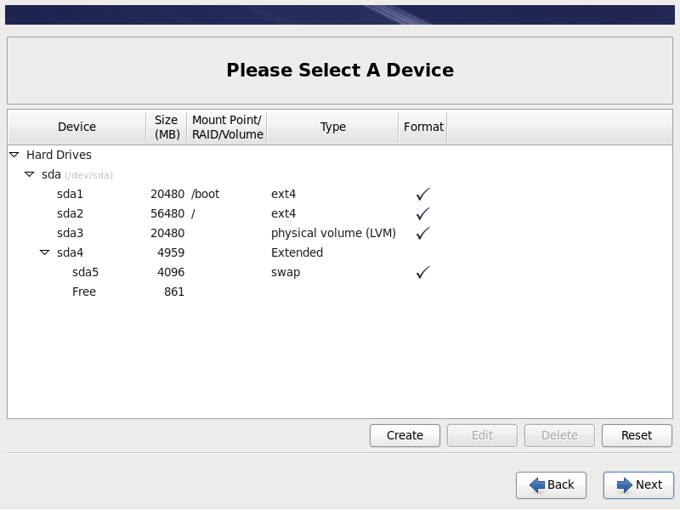

30)Click on Format option for the HDD to be cleaned before creating disk partitions. 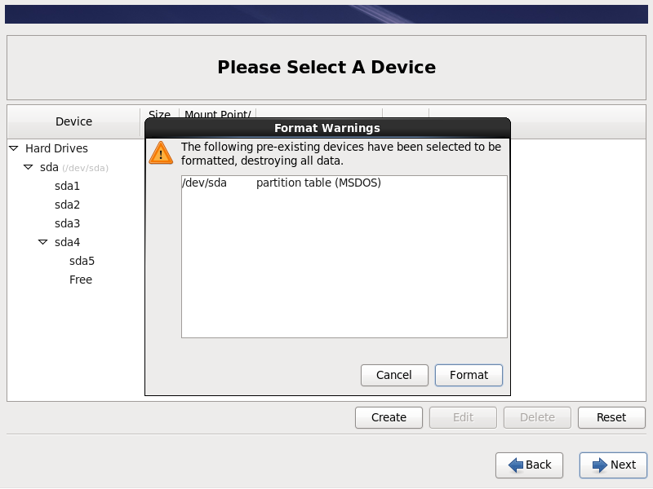

31)Click on write change to disk for the partitions to be written on HDD 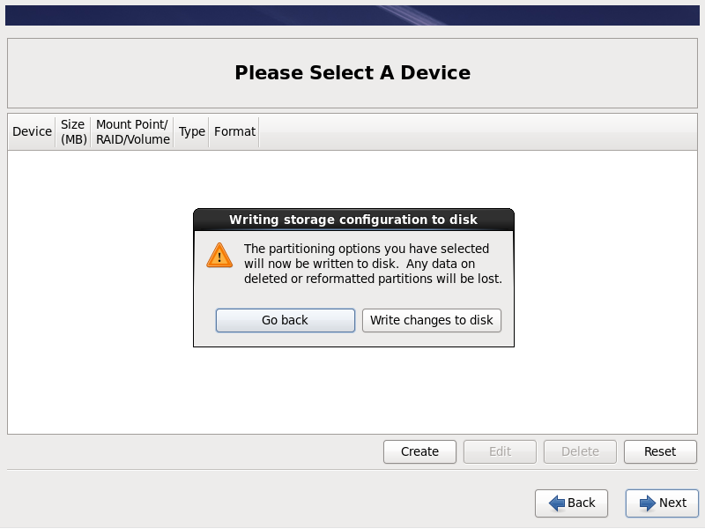

32)Select boot loader operating system for the respective /boot disk drive 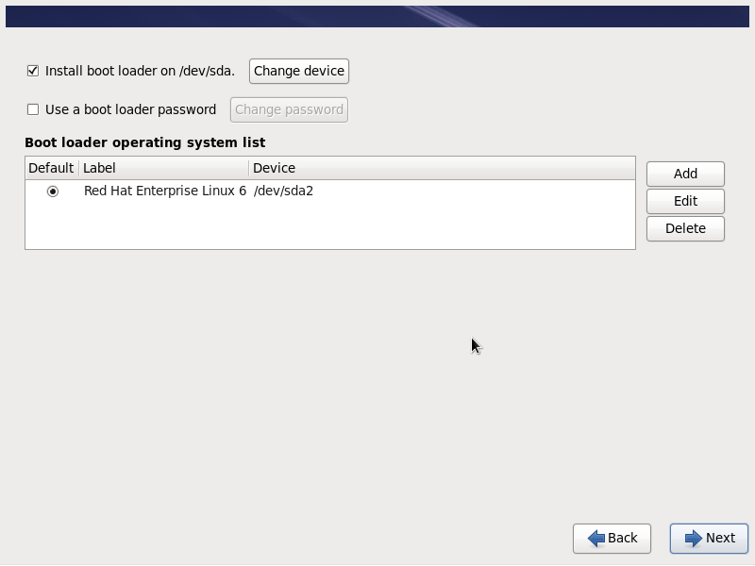

33)Choose **Desktop** type for the installation of RedHat linux operating system. 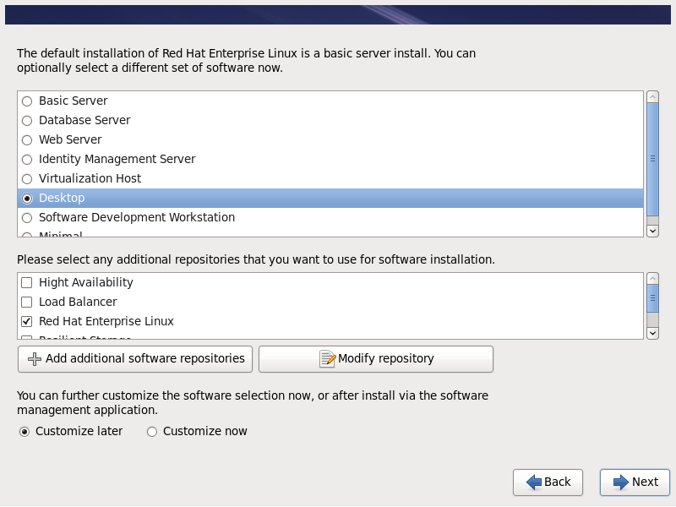

34)Click on **Reboot** for the Configurations to be written on disk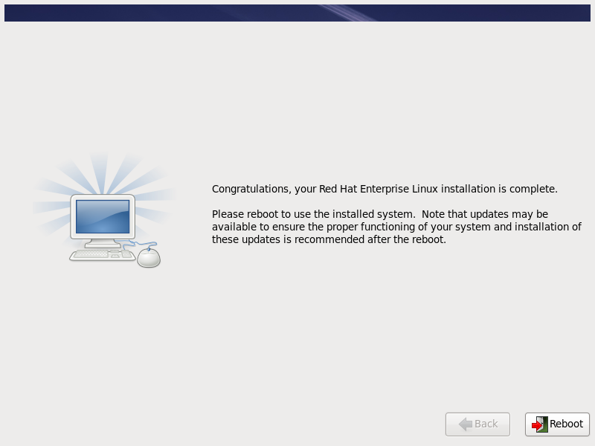

**Post VM creation tasks**

35) Click on **Forward** to proceed with the post VM creatin tasks.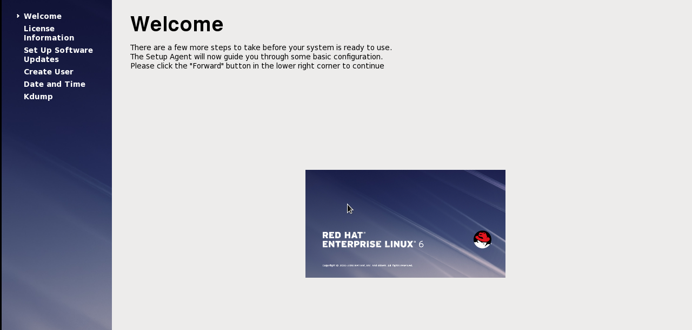

36)Click on Yes to agress with the RedHat Linux license agrement adn click forward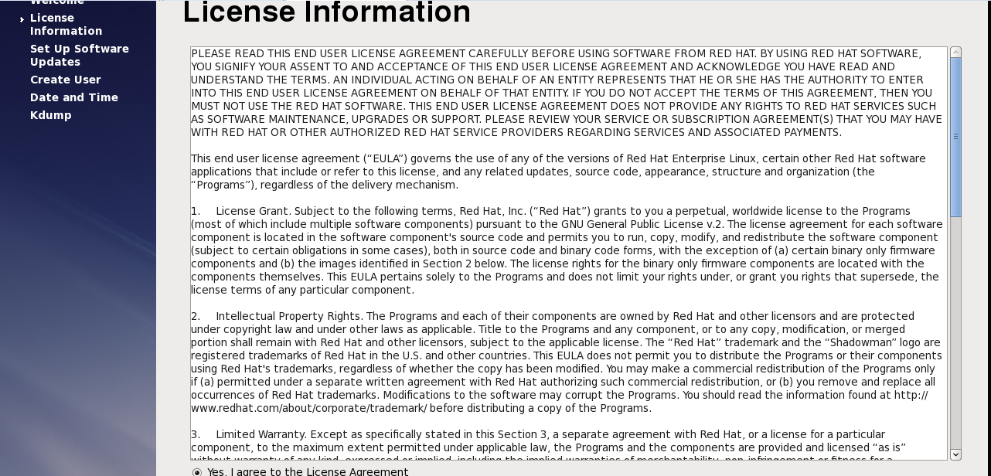

37) Setup software updates to be registered later time and click forward 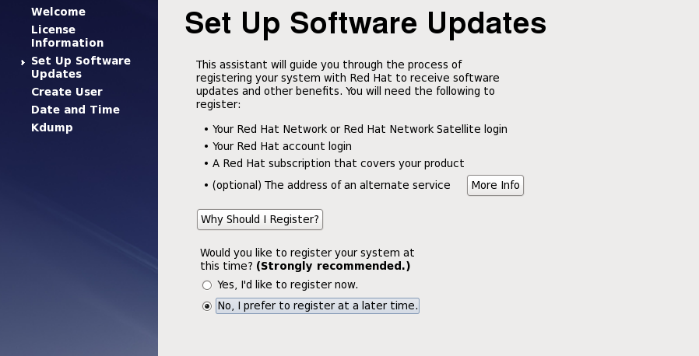

38) Click on **Register later** time for software updates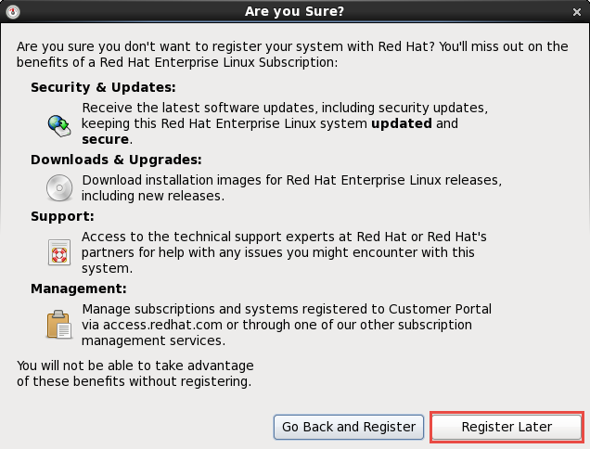

39) Click on forward to finish updates setup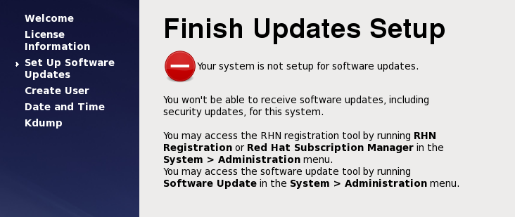

40) Create user for operating system configurations.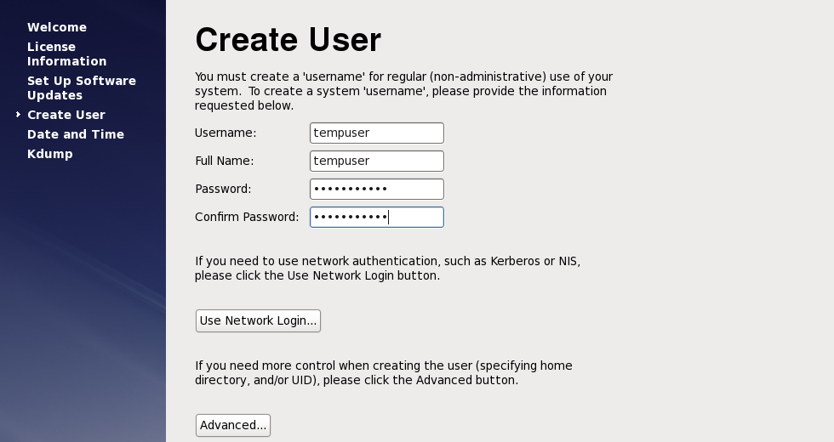

41) Click Yes for the weak password to be taken if anyway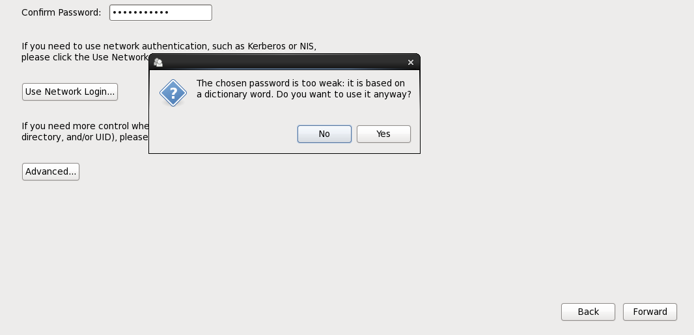

42) Tick the synchronize date and time over the network to synchronize with network.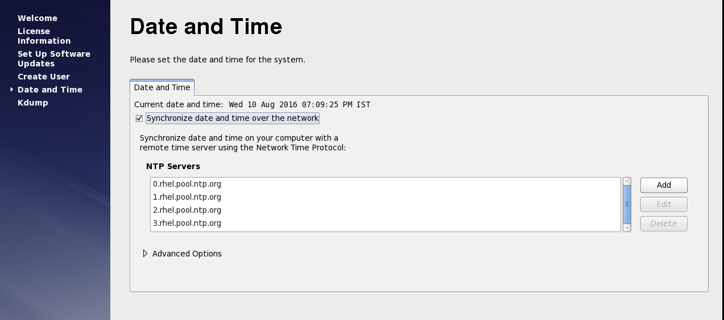

43) Click on forward option for Kdump in case on kernel crash dumping mechanism.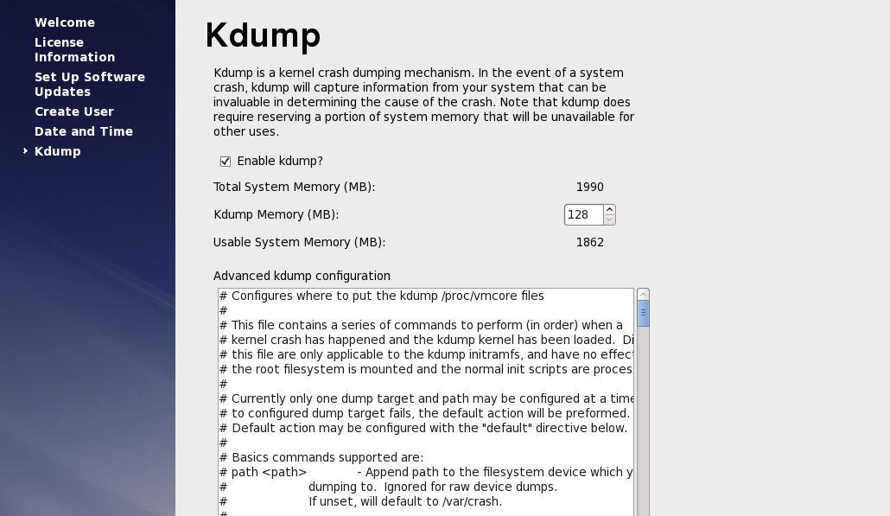

44) Click on fish and then ok to finish OS installation.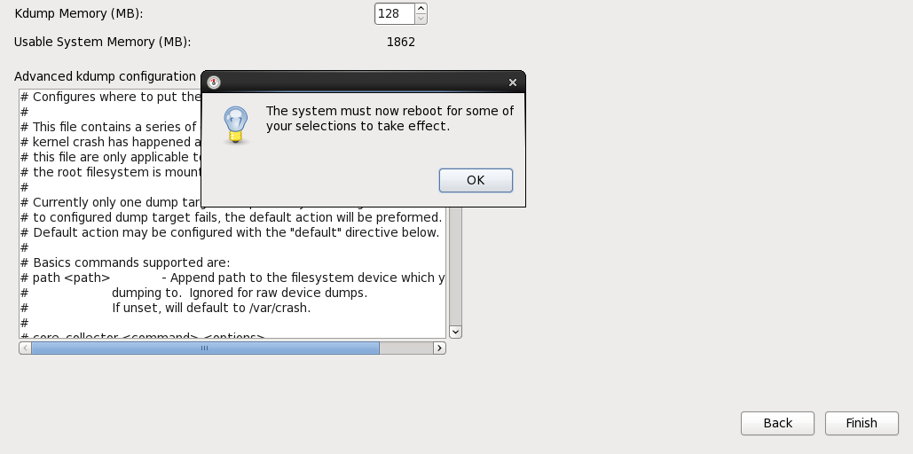

**On LVM server and On LVM Clients**

1. Mount the rhel-server-6.6-x86_64-dvd.iso file to the system.   
2. Select open a terminal window as a root.  
3. Execute the commands:   
[root@localhost]# mkdir /mnt/cdrom  
[root@localhost]# mount -o ro /dev/cdrom /mnt/cdrom  
4. Create the text file server.repo in the /etc/yum.repos.d directory.   
Note: To use gedit, execute the command:

[root@localhost]# gedit /etc/yum.repos.d/server.repo  
Add the following text to the file:   
  
[server]  
name=server  
baseurl=file:///mnt/cdrom/   
enabled=1  
  
where baseurl depends on the mounting point and the RHEL distribution.   
  
In the example, the mounting point is cdrom and the RHEL distribution is Workstation but could be sever.  
  
5. Execute the command:  
[root@localhost]# yum clean all  
6. Execute the command to import related public keys:  
[root@localhost]# rpm --import /mnt/cdrom/*GPG*  
7. Execute the commands to install the required libraries:  
[root@localhost]# yum install gtk2.i686  
[root@localhost]# yum install libXtst.i686  
If you received the missing libstdc++ message above, install the libstdc++ library:  
[root@localhost]# yum install compat-libstdc++  
yum install the following libraries as well

* yum install audit-libs.i686
* yum install audit-libs.x86_64
* yum install compat-libstdc++*i686
* yum install dos2unix.x86_64
* yum install gettext.x86_64
* yum install glibc.i686
* yum install glibc.x86_64
* yum install ksh.x86_64
* yum install libaio.i686
* yum install libaio.x86_64
* yum install libgcc.i686
* yum install libgcc.x86_64
* yum install libstdc++.i686
* yum install nss-softokn-freebl.i686
* yum install nss-softokn-freebl.x86_64
* yum install ntp.x86_64
* yum install openssh-clients.x86_64 pam.i686
* yum install pam-devel.i686
* yum install pam_passwdqc.x86_64
* yum install tcsh.x86_64 unzip.x86_64
* yum install xorg-x11-xauth.x86_64
* yum install zlib.i686 zlib.x86_64
* yum install gtk2.i686 gtk2.x86_64
* yum install gtk2-engines.i686
* yum install gtk2-engines.x86_64 libXtst.i686
* yum install libXtst.x86_64
* yum install nfs-utils

During the install you might receive prompts similar to the example. Answer with 'y'.

**Note:**

For LVM, We need to install an additional network storage server library

Command: yum groupinstall “Network Storage Server”

And install iscsi initiator utilities rpm file on lvm server and all lvm clients

Command: rpm -ivh /root/Desktop/iscsi-initiator-utils-6.2.0.873-21.el6.x86_64.rpm

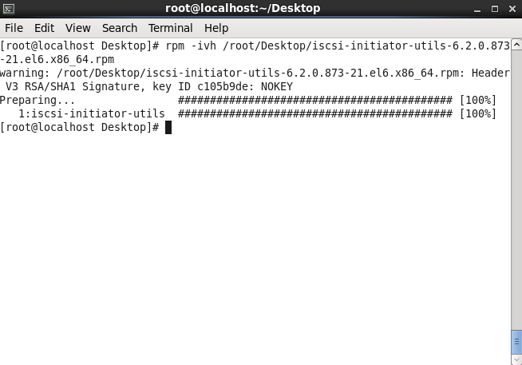

Do the following steps on all lvm server and Clients.

1. Open a terminal window, and log on as a root user.
2. Define a fully qualified name and short host name either by using a DNS server, or by creating a definition in the /etc/hosts file.
3. Ensure that the HOSTNAME value that is defined in the /etc/sysconfig/network file is set to the short host name, and that it is not set to the fully qualified host name. For example, set HOSTNAME=xyz instead of HOSTNAME=xyz.yourco.com.
4. Verify that the host name, fully qualified host name, and domain name are configured correctly on each server:
   * Enter the following command: hostname -s. The verification is successful if the command returns the defined short host name for the server.
   * Enter the following command: hostname -f. The verification is successful if the command returns the fully qualified domain and host name for the server.
   * Enter the following command: hostname -d. The verification is successful if the command returns the domain name of the server.
5. In the /etc/selinux/config file, configure the SELinux setting to either permissive or disabled. For example, to configure the SELinux setting to permissive, in the /etc/selinux/config file, edit the SELinux setting as shown in the following example and then restart the server:

SELINUX=permissive

Note: The SELinux setting must not be enabled.

1. Reboot the operating system using the following command to make the SELinux changes effective:

reboot

1. To disable the server firewalls, enter the following commands:

service iptables save

service iptables stop

chkconfig --level 123456 iptables off

1. To install the prerequisite RPM files, enter the following command:

**yum install -y audit-libs.i686 audit-libs.x86_64 compat-libstdc++*i686 compat-libstdc++_*x86_64 dos2unix.x86_64 gettext.x86_64 glibc.i686 glibc.x86_64 ksh.x86_64 libaio.i686 libaio.x86_64 libgcc.i686 libgcc.x86_64 libstdc++.i686 nss-softokn-freebl.i686 nss-softokn-freebl.x86_64 ntp.x86_64 openssh-clients.x86_64 pam.i686 pam-devel.i686 pam_passwdqc.x86_64 tcsh.x86_64 unzip.x86_64 xorg-x11-xauth.x86_64 zlib.i686 zlib.x86_64 gtk2.i686 gtk2.x86_64 gtk2-engines.i686 gtk2-engines.x86_64 libXtst.i686 libXtst.x86_64 nfs-utils**

1. Install the Red Hat Enterprise Linux packages for the X Window System on the analytics, application, and web servers.

X Windows is not required for the initial installation of IBM Intelligent Operations Center, but it is required if you want to update the underlying IBM products by using IBM Installation Manager. For example, you can update WebSphere Application Server Liberty Profile and IBM HTTP Server. You can install either the GNU Object Model Environment (GNOME) desktop or the K Desktop Environment (KDE) desktop to use with IBM Installation Manager.

1. Choose one of the following options:
   * To install the GNOME desktop, enter the following command:

yum -y groupinstall "X Window System" Desktop

* + To install the KDE desktop, enter the following command:

yum -y groupinstall "X Window System" "KDE Desktop"

1. Enter the following command: yum -y update
2. To start the desktop, enter the following command: init 5
3. To configure the GUI desktop to be the default desktop, edit the /etc/inittab file and change the value of the initdefault property from 3 to 5. The following example shows the updated line:

id:5:initdefault:

1. Save the changes, and then restart the server.

**On LVM Server**

i)List the disk partitions

Command:fdisk -l

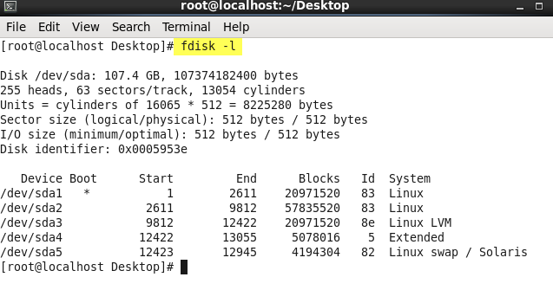

ii)‘**pvdisplay**’ shows the physical volume we have created.

Command:pvdisplay 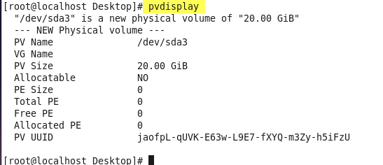

iii)Create volume group

Command: vgcreate <vgname> <lvm pv disk partition>****

iv)‘**vgdisplay**’ shows the volume group we have created.

Command:vgdisplay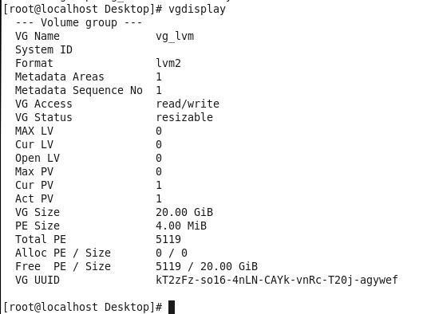

v)Create logicalvolume

Command: lvcreate -n <lvname> -L <lv space> <vg name>



vi)‘**lvdisplay**’ shows the logical volume we have created.

Command:lvdisplay 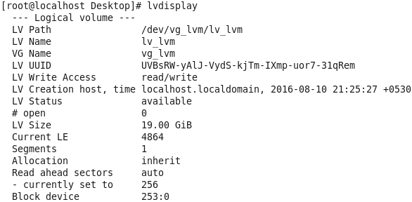

vii)List disk partitions

Command**:** fdisk -l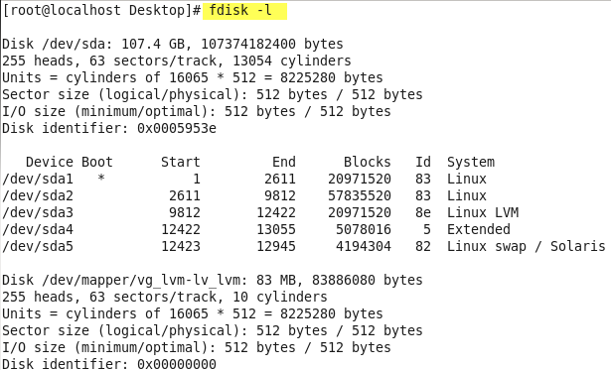

viii)Create lvm disk partition

Command**:** fdisk <lvm mapper path>

* Press n, then press p, and then press 1.
* Press Enter, and then press Enter again.
* Press w.

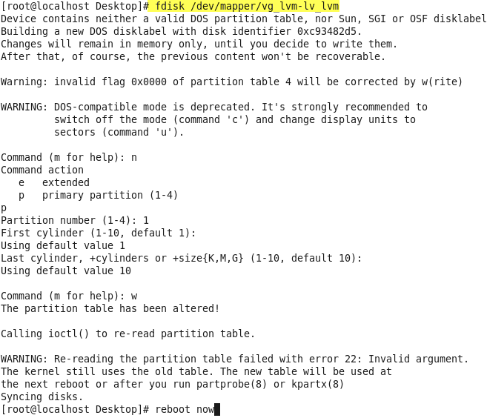

ix)Make file system

Command: mkfs.ext4 <lvm mapper path> 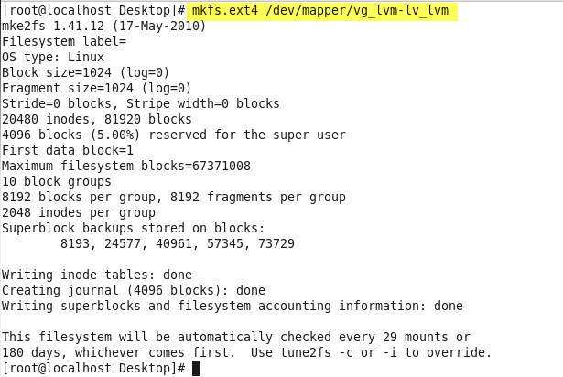

x)Edit targets.conf file and set

LVM server mapper path as backing-store and

client hostnames as initiator-address.

Command:vi /etc/tgt/targets.conf 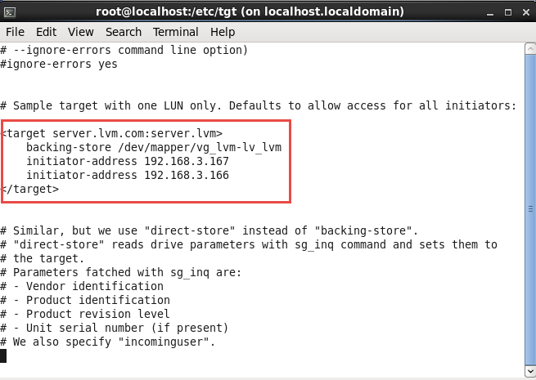

xi)Restart tgtd service

Command: service tgtd restart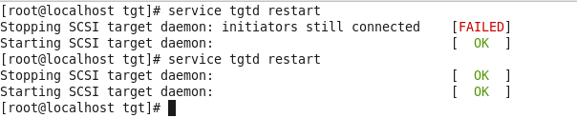

**On client1**

Now we need to do client configuration for LVM server. After the client server is ready with all the linux configuration done and hostname mapping being done

i)Restart tgtd service

Command: service tgtd restart 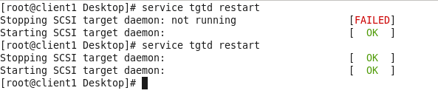

ii)Run the below command for restarting iscsi.

Command:

for i in iscsid iscsi; do chkconfig $1 on; service $i stop; service $i start; done 

iii) Discover targers

Command: iscsiadm --mode discovery --type sendtargets --portal <lvm server hostname> 

iv) Login to targets

Command:

iscsiadm --mode node targetname <target hosename> --portal <target hostname> --login



v)Check whether the shared drive is added or not.

Command:cat /proc/partitions

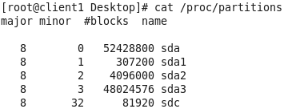

vi)Create disk partition

Command: fdisk /dev/sdc

* Press n, then press p, and then press 1.
* Press Enter, and then press Enter again.
* Press w.

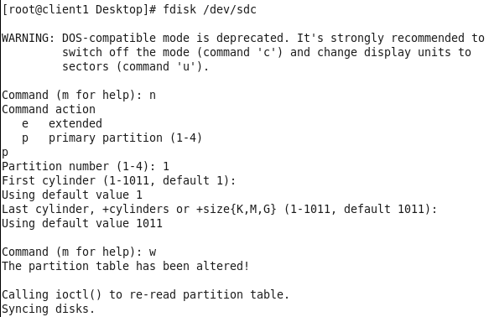

vii)Check whether the shared disk partition created or not.

Command:cat /proc/partitions

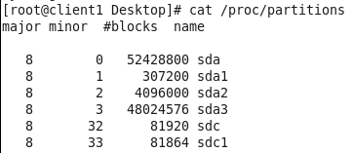

**Note:** Finish tasks on Client2 before making file system on Client1

viii)Make file system

Command: mkfs.ext4 /dev/sdc1 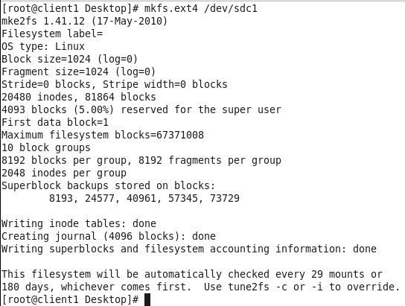

ix)Edit fstab file to append the following line to the /etc/fstab file:

Command:vi /etc/fstab

/dev/sdc1 /SANdisk1 ext4 rw,suid,dev,noexec,noauto,user,async 0 0

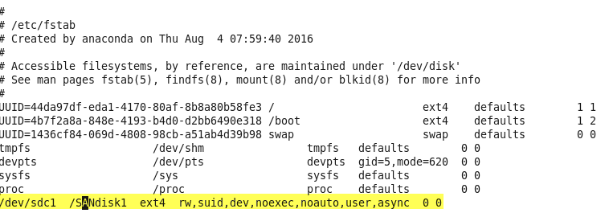

**On Client2**

Now we need to do client configuration for LVM server. After the client server is ready with all the linux configuration done and hostname mapping being done

i)Restart tgtd service

Command: service tgtd restart 

ii)Run the below command for starting iscsi.

Command:

for i in iscsid iscsi; do chkconfig $1 on; service $i stop; service $i start; done 

iii) Discover targers

Command: iscsiadm --mode discovery --type sendtargets --portal <lvm server hostname> 

iv) Login to targets

Command:

iscsiadm --mode node targetname <target hosename> --portal <target hostname> --login



v)Check whether the shared drive is added or not.

Command:cat /proc/partitions

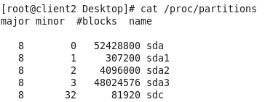

vi)On Client2, to scan a new disk partition that will create the /dev/sdc1 device

Command: partx -v -a /dev/sdc

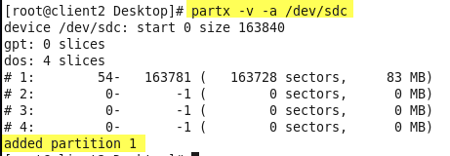

vii)Check whether the shared disk partition added or not.

Command:cat /proc/partitions

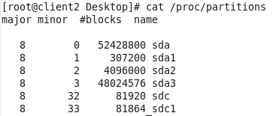

viii)Edit fstab file to append the following line to the /etc/fstab file:

Command:vi /etc/fstab

/dev/sdc1 /SANdisk1 ext4 rw,suid,dev,noexec,noauto,user,async 0 0 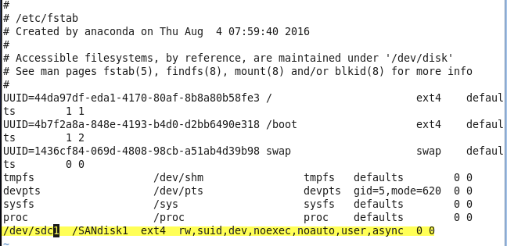

**Note1:** After finished steps on Client2, continue to finish steps from viii) on Client1.

**Note2:**Above we have the shared partition name as /dev/sdc , it may not be the same name. Example it may be /dev/sdb. For the documentation i created the LVM servers separately and i got this name for shared disk partition as /dev/sdc/

**SAN**

Prepare the storage area network (SAN) shared disk. The following steps are provided as an example.

Enter the following commands as a root user:

1. On data server 1, open a terminal window and enter the following interactive command to start the fdisk Linux application:

fdisk /dev/sdb

1. Press n, then press p, and then press 1.
2. Press Enter, and then press Enter again.
3. Press w.
4. Edit fstab file

vi /etc/fstab

1. Append the following line to the /etc/fstab file:

/dev/sdb1 /SANdisk1 ext4 rw,suid,dev,noexec,noauto,user,async 0 0

**Note:** The value that you enter for /SANdisk1 must match the value that you enter for the db2.data.logs.dir property on both data server 1 and data server 2.

1. On data server 2, to scan a new disk partition that will create the /dev/sdb1 device, enter the following command:

partx -v -a /dev/sdb

1. Enter the following commands: on both primary and secondary dataservers

Note: Make file structure after adding shared disk otherwise installation fails with this shared disk failover error message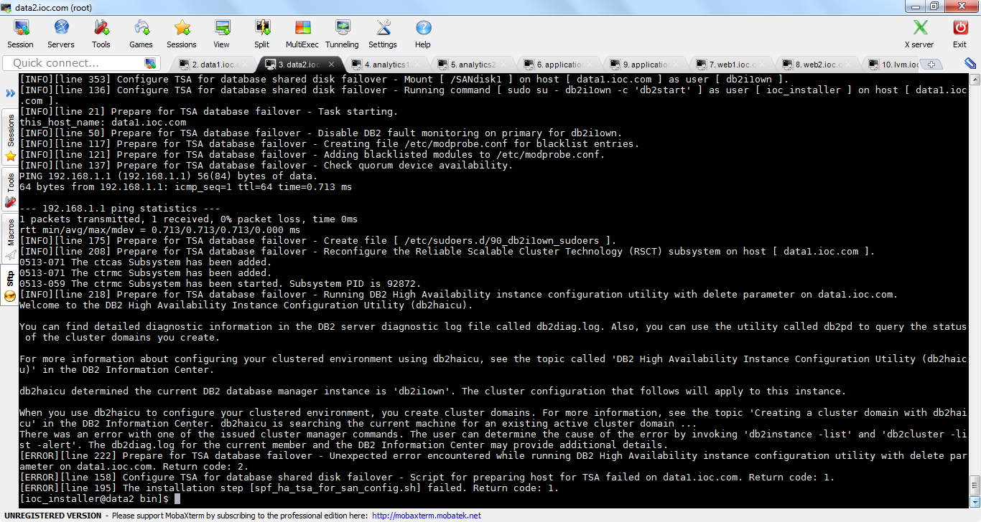

1. mkfs.ext4 /dev/sdb1
2. Enter the following command:

vi /etc/fstab

1. Append the following line to the /etc/fstab file:

/dev/sdb1 /SANdisk1 ext4 rw,suid,dev,noexec,noauto,user,async 0 0

**Note:** The value that you enter for /SANdisk1 must match the value that you enter for

the db2.data.logs.dir property on both data server 1 and data server 2.

1. To test that your mount point is working correctly, enter the following commands on data server 1 and on data server 2:
2. mkdir /SANdisk1

mount /SANdisk1

1. After the test, ensure that you unmount and remove the mount point by entering the following commands on data server 1 and on data server 2:
2. umount /SANdisk1

rm -rf /SANdisk1

## RSCT

Install RSCT packages.

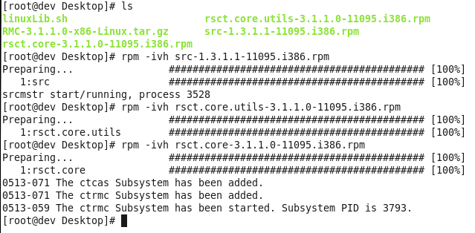

**Installing the servers in High Availability**

## About this task

Configure the four primary servers and the four standby servers in the following order, where server 1 refers to the primary server and server 2 refers to the standby server:

1. Configure data server1 and then configure data server 2.
2. Configure web server 1 and then configure web server 2.
3. Configure analytics server 1 and then analytics server 2.
4. Configure application server 1 and then configure application server 2.

**Note:** Complete steps 1-8, and optionally step 9, to configure each of the primary and standby servers before you begin step 10.

**Note:** Wait for the installation scripts to complete on each pair of primary and standby servers before you start the installation steps on the next pair of primary and standby servers.

## Procedure

Configuring the servers

**Note:** Complete steps 1-8, and optionally step 9, on each server in turn, unless indicated otherwise.

1. On the server, open a terminal window and log on as a root user.
2. Enter the following command:

cd /opt/IBM

1. Enter the following command to extract the ioc_platform.tar.gz file to the /opt/IBM directory:

tar -zxvf ioc_platform.tar.gz

Create the installation users and configure a shared SSH key between each of the servers. Create the SSH key on only one server, then share the SSH key with the other servers.

1. On data server 1, create the installation user and configure shared SSH keys:
   1. On the data server, enter the following commands as a root user:
   2. cd /opt/IBM/ioc_install/applications/ioc/bin/ioc_install_user
   3. ./s1_create_ssh_key.sh

./s2_create_install_user.sh

* 1. To copy the output files to the other primary and standby servers, enter the following command on data server 1 once for each primary and standby server, except for data server 1. In each case, enter the command on one line and replaceserver_hostname with the host name of the server that you are copying the output files to:
  2. scp /opt/IBM/ioc_install/applications/ioc/bin/ioc_install_user/ioc_rsa
  3. /opt/IBM/ioc_install/applications/ioc/bin/ioc_install_user/s2_create_install_user.sh

server_hostname:/opt/IBM/ioc_install/applications/ioc/bin/ioc_install_user/

1. Enter the following commands on each primary and standby server, except for data server 1:
2. cd /opt/IBM/ioc_install/applications/ioc/bin/ioc_install_user/

./s2_create_install_user.sh

1. To change from a root user to an ioc_installer user and go to the installation directory, enter the following commands:
2. su - ioc_installer

cd /opt/IBM/ioc_install/bin

1. Configure the installation properties in the ioc.install.properties file:
   1. To edit the ioc.install.properties file, enter the following command:

sudo vi ../cfg/ioc.install.properties

* 1. Configure each of the following installation server host name properties with the fully qualified host name of the corresponding server in the installation environment:
  2. ana.server.hostname
  3. ana.sby.server.hostname
  4. app.server.hostname
  5. app.sby.server.hostname
  6. dat.server.hostname
  7. dat.sby.server.hostname
  8. web.server.hostname
  9. web.sby.server.hostname
  10. ldap.hostname

ldap.sby.hostname

To obtain the fully qualified host name of a server, open a terminal window on the server and enter the following command:

hostname -f

* 1. Configure the value of the loadbalancer.hostname property. If you do not have a load balancer, configure theloadbalancer.hostname value to be the same as the web.server.hostname value.
  2. On the analytics, application, and web primary and standby servers, configure the values of the liberty.instance.nameproperties with the appropriate values for each server, as shown in the following table:

| *Table 1. Values for liberty.instance.name properties on each server* | | |
| --- | --- | --- |
| **Server** | **Property name** | **Property value** |
| Analytics server 1 | liberty.instance.name | iocana01 |
| liberty.instance.name.ana | iocana01 |
| liberty.instance.name.app | iocapp01 |
| liberty.instance.name.ana.sby | iocana02 |
| liberty.instance.name.app.sby | iocapp02 |
| Analytics server 2 | liberty.instance.name | iocana02 |
| liberty.instance.name.ana | iocana01 |
| liberty.instance.name.app | iocapp01 |
| liberty.instance.name.ana.sby | iocana02 |
| liberty.instance.name.app.sby | iocapp02 |
| Application server 1 | liberty.instance.name | iocapp01 |
| liberty.instance.name.app | iocapp01 |
| liberty.instance.name.ana | iocana01 |
| liberty.instance.name.app.sby | iocapp02 |
| liberty.instance.name.ana.sby | iocana02 |
| Application server 2 | liberty.instance.name | iocapp02 |
| liberty.instance.name.app | iocapp01 |
| liberty.instance.name.ana | iocana01 |
| liberty.instance.name.app.sby | iocapp02 |
| liberty.instance.name.ana.sby | iocana02 |
| Web server 1 | liberty.instance.name.ana | iocana01 |
| liberty.instance.name.app | iocapp01 |
| liberty.instance.name.ana.sby | iocana02 |
| liberty.instance.name.app.sby | iocapp02 |
| Web server 2 | liberty.instance.name.ana | iocana01 |
| liberty.instance.name.app | iocapp01 |
| liberty.instance.name.ana.sby | iocana02 |
| liberty.instance.name.app.sby | iocapp02 |

1. On only data server 1 and data server 2, configure the following properties:
   1. Configure the value of the db2.ioc.enable.automatic.storage property to true.
   2. Configure the value of the db2.data.logs.dir property to match the mount point of the shared disk, for example,/SANdisk1.
   3. Configure the value of the tsa.quorum.ip property to match the IP address of a highly available IP address that is external to IBM® Intelligent Operations Center, for example, the default gateway.
   4. Configure the value of the tsa.primary.usenic property to match the value of the current network interface on data server 1. To obtain the value, on data server 1, open a terminal window and enter the ifconfig command.
   5. Configure the value of the tsa.standby.usenic property to match the value of the current network interface on data server 2. To obtain the value, on data server 2, open a terminal window and enter the ifconfig command.
2. Optional: Edit the password property values in the installation properties file. Each password property name has the suffix .pwd. The password for sample users is configured in the ioc.sample.users.pwd property. Do not use the following special characters in password property values:
   1. Exclamation point, !
   2. Opening parenthesis, (
   3. Closing parenthesis, )

Running the installation

**Note:** The preceding steps to configure the servers must be completed before you begin step 10.

1. On only data server 1, run the following license script, read the license agreement, and enter y or Y to accept the agreement:

sudo ./ioc.accept.license.sh

1. To run the installation script, enter the following command:

**Note:** You must run the installation script on the servers in the order that is indicated in About this task.

sudo ./ioc.server.install.sh -p 8.server_initials

where server_initials is:

* + dat for data server 1.
  + sby.dat for data server 2.
  + web for web server 1.
  + sby.web for web server 2.
  + ana for analytics server 1.
  + sby.ana for analytics server 2.
  + app for application server 1.
  + sby.app for application server 2

Successful installation screen shots

Primary dataserver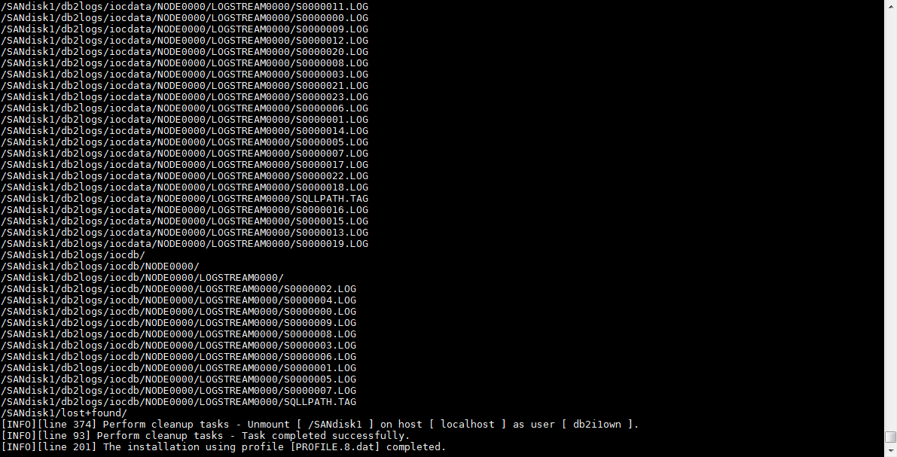

Primary web server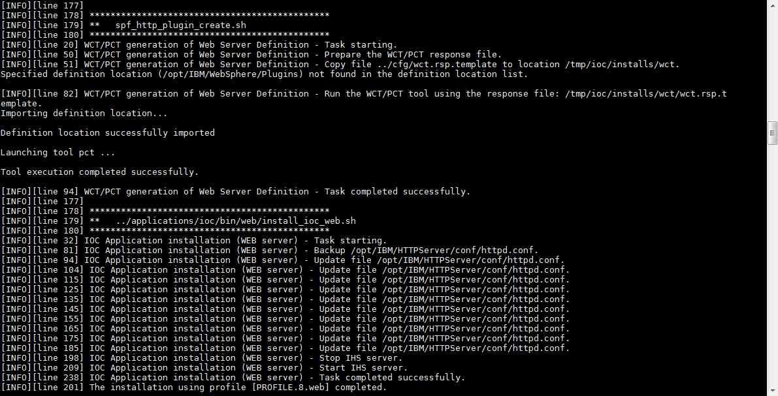

Standby webserver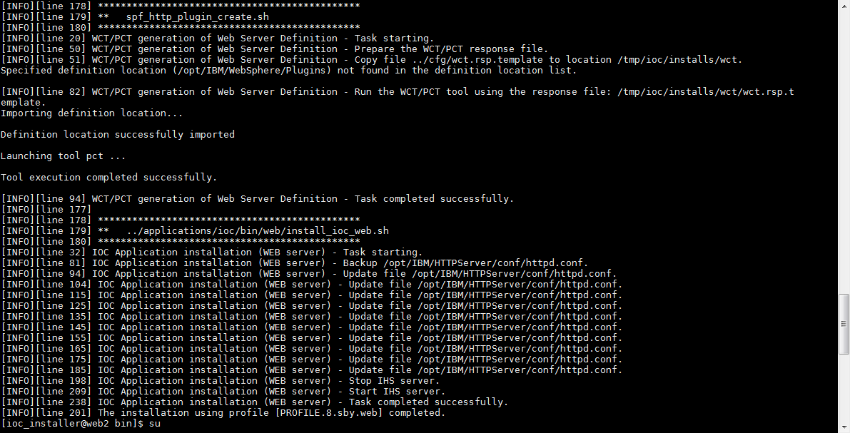

Primary analytical server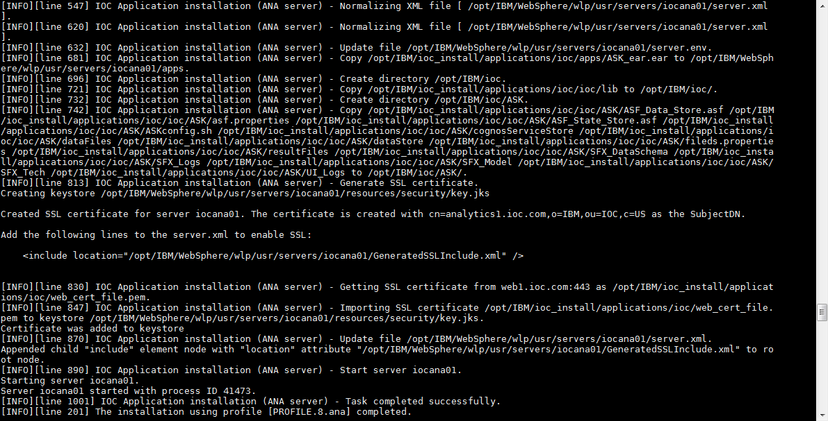Standby analytical server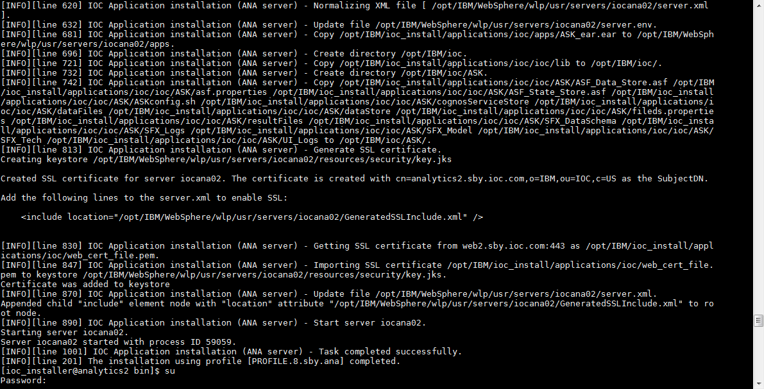

Primary application server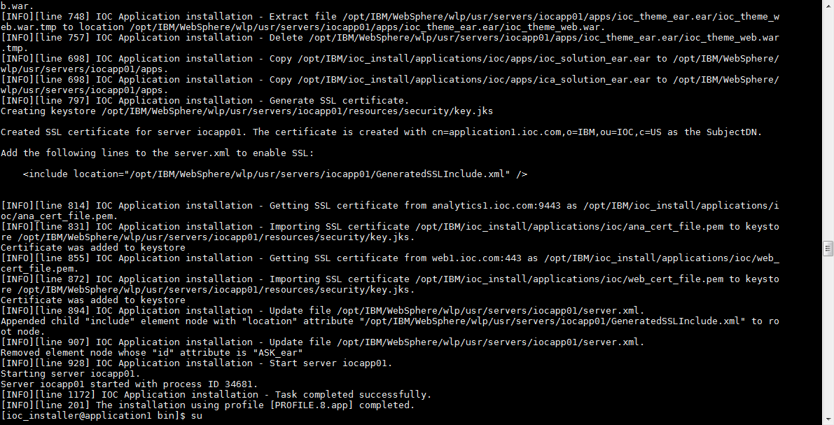

Standby application server